Set 5: Website Analytics
Aim
To visualize and analyze product inventory data using bar charts, stacked bar charts, scatter plots, and a Tableau dashboard.
DATASET: PRODUCT INVENTORY
Product ID | Product Name | Quantity Available
1 | Product A | 250
2 | Product B | 175
3 | Product C | 300
4 | Product D | 200
5 | Product E | 220

PROGRAM 1: Line Chart of Daily Page Views
Create a line chart to visualize the trend in daily page views over time. Label the axes and title the chart.
# Create website traffic data
date <- as.Date(c("2023-01-01", "2023-01-02", "2023-01-03",
"2023-01-04", "2023-01-05"))

page_views <- c(1500, 1600, 1400, 1650, 1800)

click_through_rate <- c(2.3, 2.7, 2.0, 2.4, 2.6)

# Create line chart
plot(date,
page_views,
type = "o",
main = "Daily Page Views Trend",
xlab = "Date",
ylab = "Page Views",
col = "blue",
pch = 19)

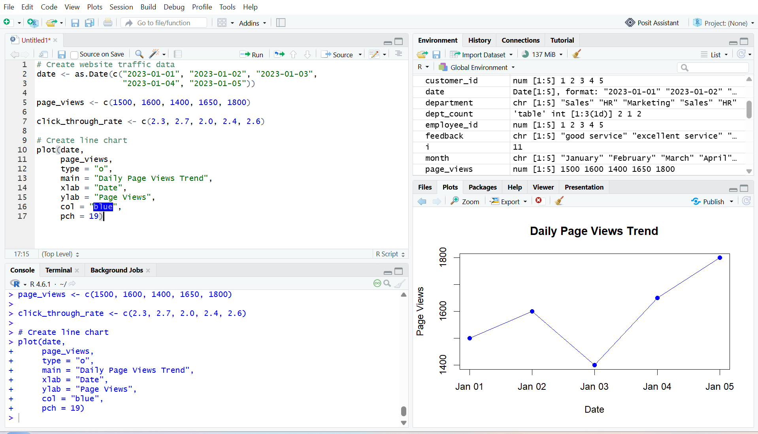
Output 1: Daily Page Views Trend Line Chart
Observation
The line chart displays the daily page views over the five days. Page views decreased on January 3 and then increased, reaching the highest value of 1800 on January 5. The lowest page views were 1400 on January 3.

PROGRAM 2: Bar Chart of Top N Days by Click-through Rate
Generate a bar chart showing the top 3 days with the highest click-through rates.
# Create website traffic data
date <- as.Date(c("2023-01-01", "2023-01-02", "2023-01-03",
"2023-01-04", "2023-01-05"))

click_through_rate <- c(2.3, 2.7, 2.0, 2.4, 2.6)

# Find top 3 days
top3 <- order(click_through_rate, decreasing = TRUE)[1:3]

top_dates <- date[top3]
top_rates <- click_through_rate[top3]

# Create bar chart
barplot(top_rates,
names.arg = format(top_dates, "%m-%d"),
main = "Top 3 Days by Click-through Rate",
xlab = "Date",
ylab = "Click-through Rate (%)",
col = "skyblue",
border = "black",
ylim = c(0, 3))

# Add CTR labels
text(x = seq_along(top_rates),
y = top_rates,
labels = paste0(top_rates, "%"),
pos = 3)

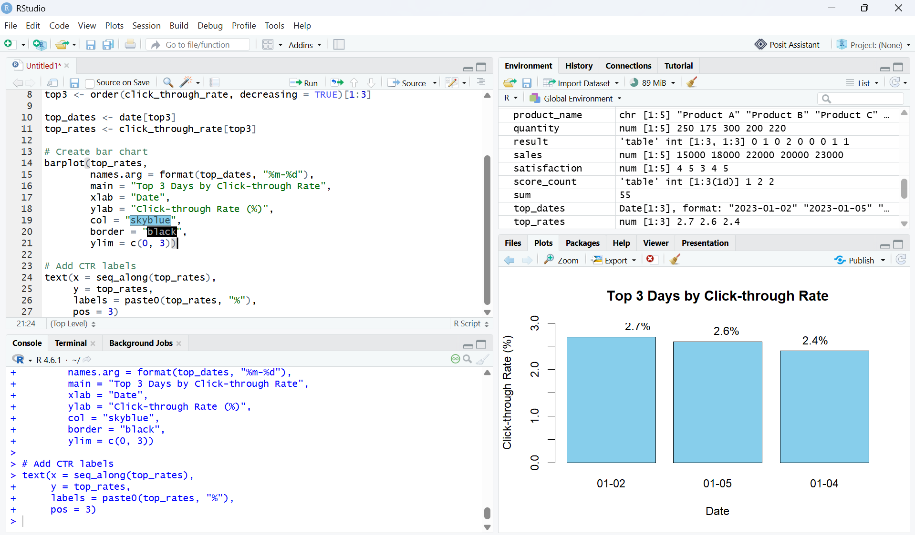
Output 2: Top 3 Days by Click-through Rate Bar Chart
Observation
The bar chart displays the three days with the highest click-through rates. January 2 has the highest click-through rate of 2.7%, followed by January 5 with 2.6% and January 4 with 2.4%.
PROGRAM 3: Stacked Area Chart of User Interactions
Create a stacked area chart to display the distribution of user interactions such as likes, shares, and comments on a website.
# Create user interaction data
date <- as.Date(c("2023-01-01", "2023-01-02", "2023-01-03",
"2023-01-04", "2023-01-05"))

likes <- c(120, 150, 100, 170, 200)
shares <- c(40, 50, 35, 60, 70)
comments <- c(25, 30, 20, 35, 45)

# Combine interaction data
interaction_data <- rbind(likes, shares, comments)

# Create stacked area chart
matplot(date,
t(interaction_data),
type = "n",
xlab = "Date",
ylab = "Number of Interactions",
main = "Website User Interactions")

polygon(c(date, rev(date)),
c(likes, rep(0, length(likes))),
col = "skyblue",
border = "black")

polygon(c(date, rev(date)),
c(likes + shares, rev(likes)),
col = "orange",
border = "black")

polygon(c(date, rev(date)),
c(likes + shares + comments,
rev(likes + shares)),
col = "lightgreen",
border = "black")

legend("topleft",
legend = c("Likes", "Shares", "Comments"),
fill = c("skyblue", "orange", "lightgreen"))
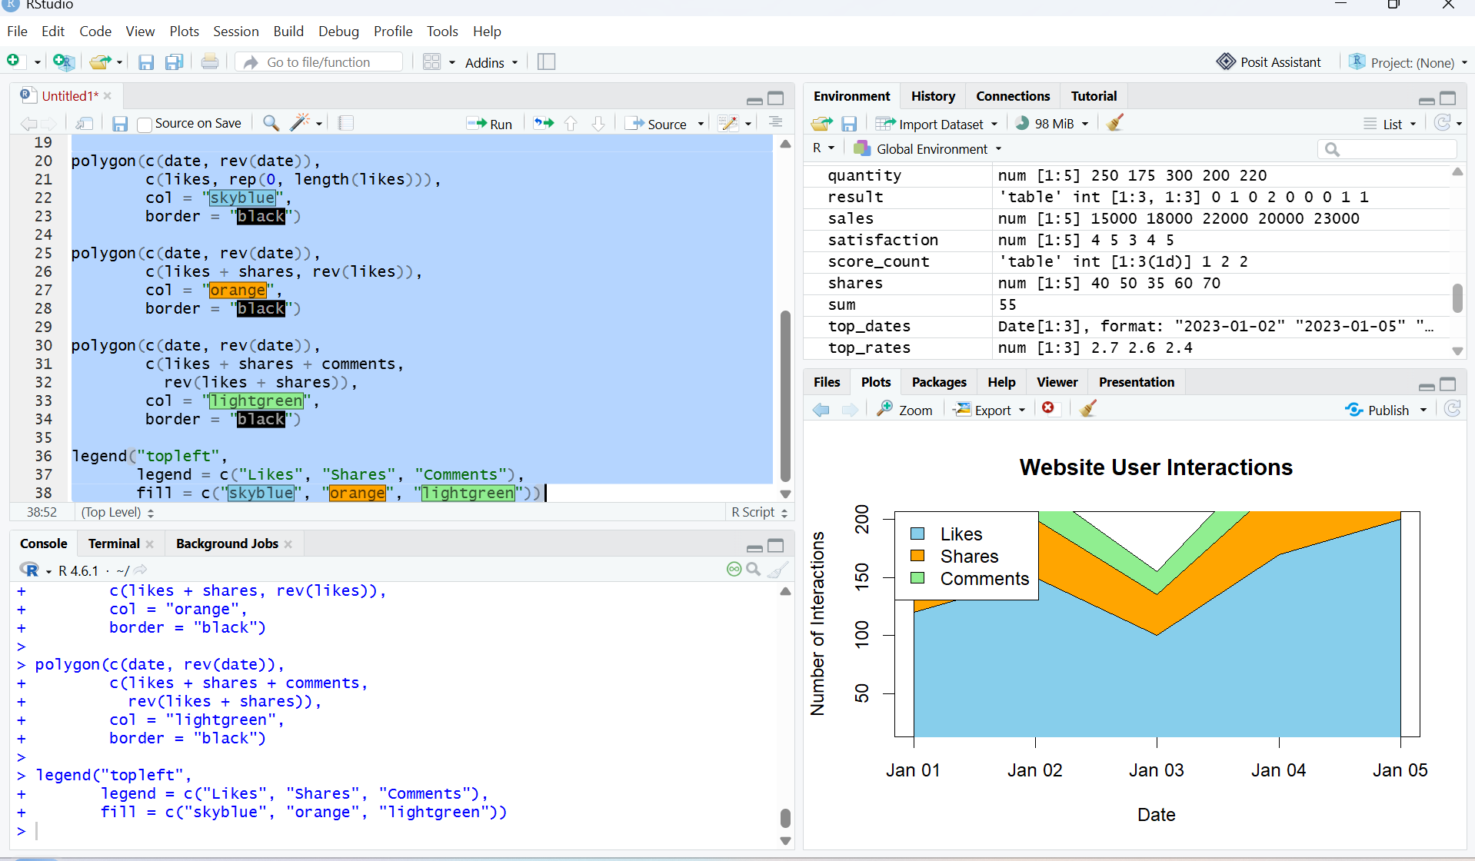
Output 3: Website User Interactions Stacked Area Chart
Observation
The stacked area chart displays the distribution of likes, shares, and comments over the five days. The total number of user interactions increases toward January 5, with likes contributing the largest share of interactions.

Note: The original Website Traffic dataset does not contain Likes, Shares, or Comments. Therefore, sample interaction values are used for this visualization.

PROGRAM 4: Tableau Dashboard for Website Analytics
Develop a Tableau dashboard with the line chart and bar chart to allow users to interact with the website traffic data.
Procedure:
- Create a website traffic dataset containing Date, Page Views, and Click-through Rate.
- Use R to create a line chart showing the daily page views.
- Create a bar chart to display the top 3 days with the highest click-through rates.
- Create a stacked area chart to visualize user interactions such as likes, shares, and comments.
- Import the Excel website traffic dataset into Tableau.
- Create a line chart in Tableau using Date and Page Views.
- Create a bar chart in Tableau using Date and Click-through Rate.
- Apply a Top N filter to display the days with the highest click-through rates.
- Combine the line chart and bar chart into a Tableau dashboard.
- Add filters or dashboard actions to allow users to interactively explore the website traffic data.
- Save the Tableau dashboard.

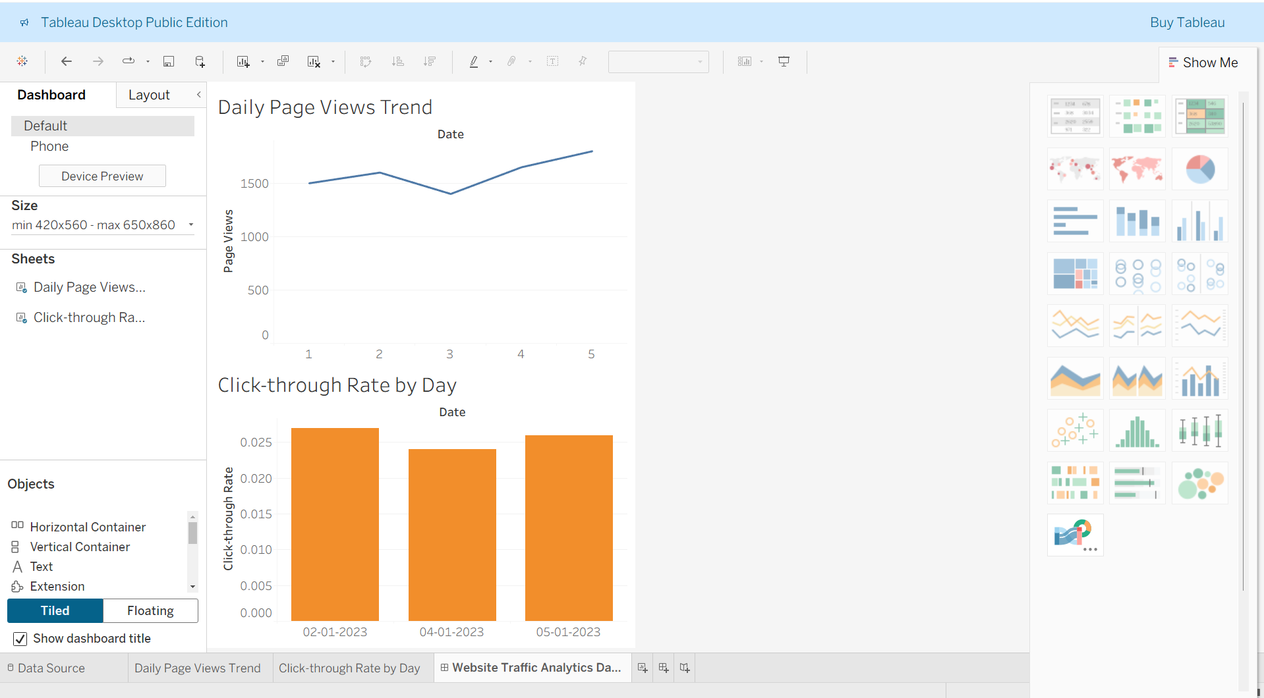

Output 4: Website Traffic Analytics Dashboard

Observation
The dashboard displays website traffic using a line chart and bar chart, allowing users to compare daily page views and identify the days with the highest click-through rates. Interactive filters provide convenient exploration of the website traffic data.

Set 5 Procedure
- Create a website traffic dataset containing Date, Page Views, and Click-through Rate.
- Use R to create a line chart showing the trend in daily page views.
- Create a bar chart to display the top N days with the highest click-through rates.
- Create a stacked area chart to visualize the distribution of user interactions such as likes, shares, and comments.
- Import the website traffic dataset into Tableau.
- Create a line chart and bar chart in Tableau.
- Apply filters and dashboard actions for interactive exploration.
- Combine both charts into a dashboard and save it.
Set 5 Result
Website traffic data was successfully visualized using an R line chart, bar chart, and stacked area chart. A Tableau dashboard was also created to display and compare daily page views and click-through rates interactively.

